**DRAFT**

**Overview of Current GTDS Measurement Selection Processing in the FDF**

**With Sample Use Cases**

**Current FDF Processing Using GTDS:**

Since the FDF is a multi-mission facility with many missions, the tracking data collection is generalized and data is stored by measurement types in a SQL database in its raw format. At OD processing time, the data is requested from the SQL database via a Data Packager call to the database to retrieve the data measurement by measurement type, 7-digit satellite ID, and time, and convert it to 60-byte data for use in OD processing. The 60-byte format is the only format supported by GTDS. (The processing to the sequential filters is different than shown in this overview and not covered here). The Data Packager call is appended by the GTDS setup for the individual mission to process the data returned by Data Packager.

At each individual mission level the OD scripts are set up for each mission retrieving the data types needed by time span. For example, the tracking data for Mission A is retrieved for the past 2 days beginning at 00:00 GMT and ending close to the current time span. Each span is individualized to that mission and contains common data with the subsequent solution span to be processed at the following OD update.

There are multiple GTDS keyword cards that specify the data to be used. The first is the CONTROL keyword card that contains the satellite name and the 7-digit satellite ID as well as what type of GTDS run this is, which in the case of an OD run it specifies DC for differential correction. Although there is a 7-digit International Designation code that is assigned for each satellite which is announced post launch, FDF commonly uses an internal construct for creating the number and stays with that internal convention generally. This simplifies FDF processing because the announcement is made post-launch and FDF has been processing all the pre-launch data for months and through the launch period and it is simply more convenient to stay with the same number instead of breaking the configuration and converting the data to another number when the FDF is busy with the launch day processing in progress. This 7-digit code internally is only used for data management and OD processing. All external deliveries for missions use the 4-digit NASA Satellite Identification Code (SIC) code which is the networks convention. The 4-digit NASA ID which is mission unique is combined with a somewhat arbitrary 3-digit code which usually ends with one (1 corresponds to a NASA vehicle ID convention that indicates the object is a satellite payload). The SATID and the SICs are linked in a table that GTDS reads as input. *GTDS will read and use the data is the 7-digit satid is the one specified in the GTDS KWC but the name is wrong.*

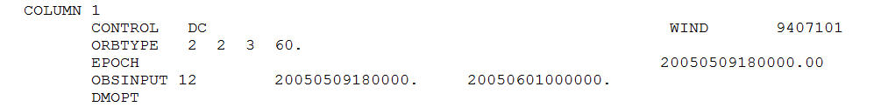

Although the data is stored by 7-digit code and retrieved by the 7-digit code, it is possible to link special test areas to special test data by creating test 7-digit codes if needed. This provides a lot of flexibility for prelaunch tests and data flows. Further, within GTDS, it is possible to include alternative satellites in the OD processing via the GTDS keyword card SATGROUP. This is useful if a network or C-band tracker has mis-identified an object and it should be processed with the mission data even if a different NASA 4-digit SIC code has been assigned to the incoming data or whether another non-NASA network has mis-tagged their data such as US STRATCOM or the US Air Force. This data typically comes in with 5-digit codes.

The next important data measurement selection keyword card (KWC) is the OBSINPUT card. This specifies the data span to be used in the OD run as well as indicates the type of measurements to be used. For example in this WIND OD run, the ‘12’ immediately following the OBSINPUT indicates that the data is being read from a file on ftn91. This is followed by the start and end time of the data to be processed in the OD run.



The next data measurement specification is made in the DMOPT sub-deck. This is the ***DATA MANAGEMENT options section***. This is also followed by a DCOPT sub-deck, which is a ***DC options*** specification. Anything included in the first DMOPT sub-deck is used to pull in the data and retain it in the observation working file. But what is selected in the DCOPT sub-deck is what is actually being retained in the OD processing. By placing editing criteria in the DMOPT sub-deck instead of the DCOPT sub-deck, the data editing will be performed at the observation working file level. Hence if data is deleted, it will be deleted from the observation working file and not appear further in DC or SOR processing.

However, if the data is still retained through the DCOPT sub-deck, than the data will still be available for OD processing. The data can be deleted here in the DCOPT, but statistics can then still be gathered on the data in the SOR processing. This is very useful, as it allows the user to evaluate the quality of the data without including it directly in the orbit estimation. This is useful for new tracker certification where data from a new tracker is compared with data for the same object against other already certified trackers. Also, it is useful for early mission support, where one set of data may be suspect and it is still under evaluation. It can be removed from the OD processing, but the quality of the data can be compared to the other data in the SOR.

The data editing occurs through the use of the ACCREJ keyword card in GTDS. The formatting of the way this card is set up enables many different data editing approaches. If this section is not available, then all data between the observation start time and the observation end time on the OBSINPUT card will be used in the OD, regardless of data type if for this target mission (specified on the CONTROL card).

This card is laid out as follows:

0---+----1----+----2----+----3----+----4----+----5----+----6----+----7----+----8

ACCREJ 40

Number of accept/reject cards to follow with detailed instructions (max of 40 in GTDS)

Accept/Reject card

The keyword card ACCREJ is in the first 8 alphanumeric fields (1-8) which specifies that it is defining the Accept/Reject instructions. The actual number of cards to follow is specified in the integer field of 3 (i3) that is in columns 9-12. In the example above, 40 lines of accept and reject specifications are to follow. These integer columns are right-justified.

The actual specifications for the accept/reject are made via the A and D cards. The data type selection specification as well as any time selection (optional) are made in the 3 real columns that are typically referred to as starting in column 20, 40 and 60 as it is easier to remember (actually they are cols. 18-38, 39-59, and 60-80). The first 8 columns of this card again specify what card it is, as well as enable giving a station ID also. The layout of this card is as follows:

3 fields of real 21s

(cols. 18-38, 39-59, 60-80)

3 fields of integer 3

(cols. 9-11, 12-14, 15-17)

0---+----1----+----2----+----3----+----4----+----5----+----6----+----7----+----8

ACCREJ 4

A DS24 1 10001300. 20141001010100.0 20141002010000.0

Data observation span

Data type selection

Alphanumeric field (cols. 1-8)

The A and D cards are laid out in exactly the same format, and contain the same options. The data can be optionally accepted or rejected or further edited by and/or combinations of these choices:

* Station acronym
* Tracker data type (as defined in GTDS)
* Object number
* Ground transponder ID
* Equipment mode
* Data rate sampling
* Start and end time
* Nth time selection

The ACCREJ keyword card contains the specifications for the data to be used. This setup is the same whether in the DMOPT or DCOPT. These control whether the data is to be included (‘A’ or accepted) or rejected (‘D’ or deleted).

The data acceptance/rejection via the ACCREJ is a little complicated in GTDS. These rules describe the process:

* If no criteria is specified, then all data is accepted for further processing.
* If there are no A or accept cards, then all data is accepted for further processing unless it meets the D or delete criteria.
* If there is at least one A or accept card, then all data is deleted unless it meets the accept criteria.
* If an observation meets both acceptance and deletion criteria, then it is deleted.

Data to be edited must satisfy the station acronym, tracker type, object number, and ground transponder ID edit criteria one of the three tracker type, mode, and rate combinations specified; the data must fall within the edit timespan and must not have been selected by another A or D card. Data selected and meeting these criteria will then be subjected to the frequency test before being accepted or deleted.

GTDS uses these rules for processing the accept/delete cards:

1. The Accept and Delete specifications cards must be preceded by an ACCREJ card. No more than 40 specification cards may appear in a single DCOPT or DMOPT subdeck.
2. For accept by tracker types, when the ALL*X* option is used, all stations with the same tracker type are used. For example if ALL3 is input all stations with the last character of “3” or “A” will be used since their tracker types (5) are identical.
3. TDRS ID = SIC – 1299, where SIC = Support Identification Code. (The TDRS ID should be the actual number in hexadecimal contained in the 60-byte observation data for the forward link or the return link). For example a TDRS ID of “10” in decimal must be specified as an “A” (hexadecimal equivalent) in the field.
4. Up to three combinations may be specified in columns 18-38 (first real field for data type selection). A single combination is given as TTMR.0, two combinations as TTMRTTMR.0, and three combinations as TTMRTTMRTTMR.0. Each combination must be represented by four digits. If the type is a single digit, it must be preceded by a zero. If type, mode, or rate editing is not to be performed, the appropriate position should be filled by a zero.
5. If the start time is equal to the end time, all other information on this card will be ignored. The editing will be treated as a single point edit, and all observations which occur at the single edit time, regardless of tracker type, will be deleted.
6. If frequency for the Accept is by time (every Nth second), then set this field (columns 12-14) to -99 and follow with a ‘SAMPLRE’ keyword card.

The tracking type is as defined in GTDS. These are the main selectors for data types in GTDS. These values are taken from the GTDS User’s Guide and are shown in the Appendix at the end of this document. The second column is the GTDS Type Number. For instance 85 is the Space Network (SN) range type, this is relay tracking of a TDRS user.

**Tracking System Associated with the Last Character of Tracker Acronyms**

**(From GTDS User’s Guide Table 4-1).**

| **Value of X**  **Last Character of Tracker Acronym** | **Tracking System** | **Tracking System Number** |
| --- | --- | --- |
| V  M  T,Q,F  G  3  S  A  X,Y,Z  R  B  D  S  L  C  E,4  K  J  6  U  6  7  Otherwise | GRARR-VHF  Minitrack  C-Band  GRARR S-band  USB MARK 1 or SRE, N-S keyhole  USE Mark 1 or SRE, E-W keyhole  USB Mark 1 or SRE, E-W keyhole  SRE-VHF  ATSR  ATSR Ground Transponder  DSN  SRE N-S Keyhole, TT&C  Laser  Optical  X-Y Parabolic  TDRSS  TDRSS Ground Transponder  V&C  NORAD  DSN 26-meter USB  DSN 9-meter USB  DSN Mark IVa | 1  2  3  4  5  6  6  7  8  9  10  11  12  13  14  15  16  17  18  6  5  10 |

**Equipment Mode Indicators**

**(Table 4-3 from the GTDS User’s Guide)**

| **Index Number** | **C-Band** | **Minitrack** | **USB** | **ATSR** | **TDRS**  **(Forward-Link Service, Return-Link Service)1** |
| --- | --- | --- | --- | --- | --- |
| 0  1  2  3  4  5  6  7  8 | Any  Beacon  Skin | Any  Equatorial  Polar | Any  Mark  SRE | Any  Sidetone  Coherent  Satellite Phase-Locked-Loop Transponder  Satellite Crystal Transponder  Ground Crystal Transponder  Ground Phase-Locked-Loop Transponder | (Any, Any)  (Forward-Link Service NE Return Link) 2  (MA, MA)  S-Band (SA1, SA1) or (SA2, SA2)  S-Band (SA1, SA1)  S-Band (SA2, SA2)  K-Band  (SA1, SA1) or (SA2, SA2)  K-Band (SA1, SA1)  K-Band (SA2, SA2) |

**Data Rate Indicators**

**(From Table 4-4 of the GTDS User’s Guide)**

| **Index Number** | **ATSR** | **GRARR** | **TDRSS** |
| --- | --- | --- | --- |
| 0  1  2  3  4  5  6  7  8 | Any  1/second  2/second  4/second  5/second  6/minute | Any  1/second  2/second  4/second  5/minute  1/second  2/second  4/second  6/minute | Any  >= 40/minute  Between 40 minute and 8 minute  =< 9/minute |

In FDF the common ways to schedule data is mostly by tracker, data type, or time. The equipment mode is used sometimes; have not seen the rate selector used (via the TTMR selection) but choosing the data rate by the Accept/Delete (A or D) or via the SAMPLRTE is common.

**Examples:**

**Example 1: Demonstrate selection by tracker, data rate, and data type.**

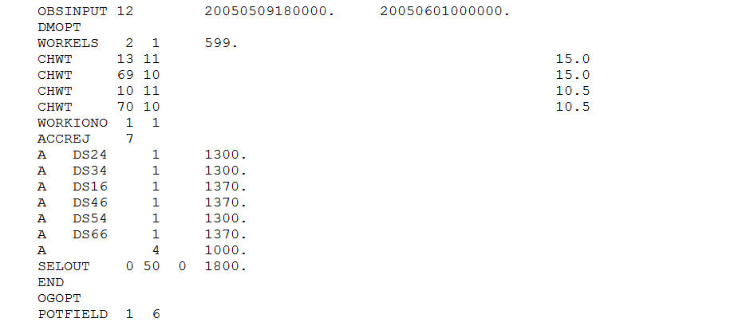

The example above says that 7 KWCs follow that contain the specifications for data selected. In this example, individual trackers have been selected using their 4-digit tracker acronym along with the selected tracking measurement type using every available point (the ‘1’ in the second integer column). For example, the first line reads that to include DS24 data at every measurement, using the range measurement via the OBSERVATION TYPE indicator pulled from Appendix A-2 of the GTDS UG (‘13’ with a ‘00’ subtype).

The data can be selected based on time, data type, stations, and various modes. GTDS has a limitation of 40 individual A or D KWCs.

Data thinning or sampling is accomplished in either of two approaches. The first is as above, where on the A card, the data thinning is specified. For example, on the last A KWC shown above a 4 is shown. This indicates that only every 4th observation will be used of data type range-rate.

**Example 2: Data Sampling by Choice of Rate:**

Another approach is to use the SAMPLRTE card to select the data thinning needed. In this case, two cards are required. First card is the A or accept card where a -99 in the second integer field indicates that the next KWC will specify the data rate to be used for this data selection. In the example below a 20-second interval is chosen to be used for the Doppler data. The A card with the -99 is specifying that Doppler data is selected, and it is to be selected by the rate of every 20 seconds (via the SAMPLRTE card).

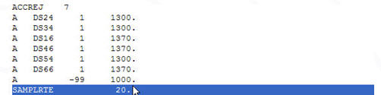

The range data in this example is selected by station and tracking type. The equipment mode is used in several of the examples, 1370 here where the ‘7’ is the mode specification and ‘13’ is the selection of the range data.

**Example 3: Changing the Validity Flag on Data to Make Available for OD Processing:**

This example uses all data as no accept/reject cards are used so GTDS will use all data passed to it in this instance, as no ACCREJ card is present and there is no A or D cards. Further, the validity flag on the data has been set by the tracking site and marked as invalid from the site. However, upon close inspection the user may decide to override the validity flags and allow the data use in the OD processing. This is a rare example of use as normally the flag would be respected but in cases this may be an option that is useful to perform.

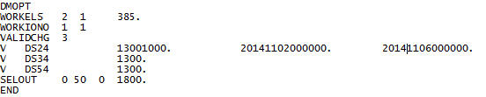

In this example, in the first case the validity flags for the range data (‘1300’) and the Doppler data (‘1000’) is overridden for the time period of Nov. 1-6, 2014 for data from DS24 antenna only. This means that the data contained in the OD span outside of this span – the validity flag will be respected. Whereas with the other sites the flag is overridden for all the data processed from DS34 and DS54 in the OD processing for this run.

The second case and third case, all of the range data validity flag is overridden if marked invalid for the sites DS34 and DS54. So this makes this data available for OD.

**Example 4: Editing by Time**

This example selects all range and Doppler between Oct. 1st and Oct. 4th at the available rate in the data. Then it deletes all range data (via the ‘1300’ specification in the first real field in column 20) between Oct. 2nd and Oct. 3rd from DS24 via the delete card (‘D’).

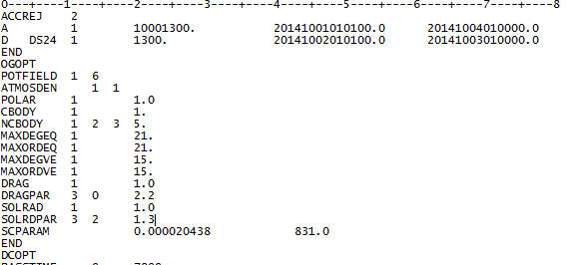

**Example 5: Editing Data by Type**

This example illustrates other combinations of data selection.

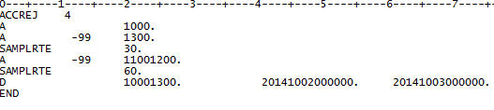

The Doppler data is selected for the whole span (‘10’ of the 1000). The range data is selected for the whole span at a sample rate of every 30 seconds (‘13’ of the 1300). The angle data is accepted for the whole span at a data sampling rate of every 60 seconds. All the range and Doppler data between 10/02-10/03 is deleted.

Although it is possible to specify up to 3 data types on one accept card, sometimes it is better to have them separated. Especially if the support is a launch or early orbit period and you want to utilize the data in different combinations as need be for assessment purposes. In these cases, it is easier to have different lines specifying the data inclusion so the data can be manipulated as desired.

**Example 6: Selecting SN User (Relay) Data:**

This data illustrates selecting TDRS User data.

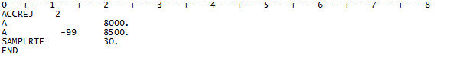

In this example the TDRS tracking of a SN user is chosen. The ‘8000’ is the range data (actually the ’80’ of the 8000). The ‘8500’ is the Doppler data (actually the ‘85’ of the 8500). The Doppler data has been sampled down to every 30 seconds.

**Example 7: Selecting SN Ground Transponder Data:**

This example illustrates selecting TDRS ground transponder data (BRTS):

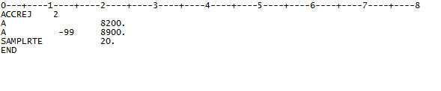

The 82 of the ‘8200’ field is the selection of SN BRTS tracking. The 89 of the ‘8900’ field is the BRTS Doppler data.

**Example 7: Selecting SN TT&C Range Data (TDRS Ground Terminal to TDRS):**

This example illustrates adding the SN TT&C tracking to the BRTS data.

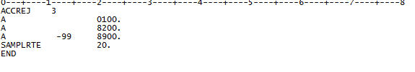

The 01 of the ‘0100’ is the addition of the TT&C range data.

**Example 8: Selecting SN Differenced One-Way Doppler Data (DOWD) and 2-way SN User Data:**

This example illustrates using the SN DOWD from two one-way Doppler streams simultaneously. This data type is formed from two simultaneous return 1-way from TDRS user to White Sands at rate of 1:1. The two way range and Doppler data has also been selected for this OD run.

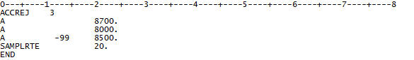

The DOWD is selected by the 87 in the ‘8700’ field.

**Example 9: Selecting SN Differenced One-Way Doppler Data (DOWD) plus GN Angle Data:**

This example illustrates using the SN DOWD from two one-way Doppler streams simultaneously as above. For launch and early orbit support for non-coherent missions, this data is scheduled along with angle data from ground network tracking assets.

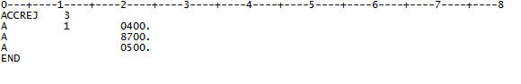

Azimuth angles

DOWD

Elevation angles

The GN angle data is specified via the ‘04’ in the 0400 and the ‘05’ in the field.

**Example 10: Constellation OD for SN User and SN Relays:**

This example illustrates using BRTS, TT&C, as well as TDRS User data in one OD run. The SN relay satellite positions are also being estimated in this OD run as well as the target satellite.

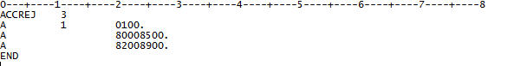

The TDRS relay positions will be estimated by the TT&C range data (0100), and the BRTS transponder data (8200 and 8900), and then the TDRS user position is estimated by the range and Doppler data for the TDRS user (8000 and 8500).

**Example 11: Constellation OD for SN User and TDRSS Alternative Example:**

This example illustrates another approach for the constellation OD:

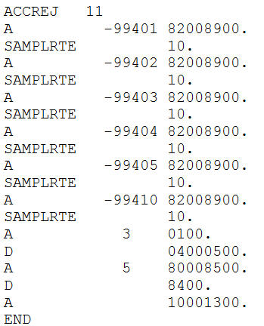

In this example, the TDRS relay data is sampled by individual TDRS (‘401’, ‘402’, etc.). The TT&C range is also sampled to 1:3. The GN angle data is deleted. The TDRS user data for the target satellite is sampled at the 1:5 rate for both range and Doppler data. The TDRS one-way data is deleted. Range and Doppler data from ground networks is included at the full rate.

**Example 12: Selecting SN Relay Data by Ground Transponder:**

This example takes in TT&C and BRTS data to estimate a TDRS relay position; however, one of the ground transponder’s data is deleted (ACNJ).

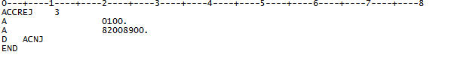

**Example 13: Selecting C-band Tracking:**

This example takes in C-band tracking data.

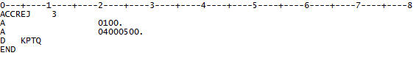

The C-band range is the 01 in the 0100 field. The C-band angle data is added with the 0400 and 0500 data selection (04 for azimuth and 05 for elevation). One site of data is rejected for Kaena Pt. HI if it is present in the data for the entire span.

**Example 14: Selecting NORAD Tracking:**

This example is very similar to the C-band tracking selection.

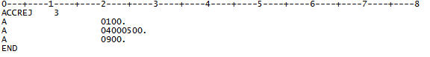

Here 0100 is the NORAD range selection. The 0900 is the NORAD Doppler selection, and the angle data is again 0400 (azimuth) and 0500 (elevation).

**Appendix A2. GTDS User’s Guide Observation Type Indicators**

